**ZipDocs**

**A SUMMER INTERNSHIP REPORT**

On

Document Management System

*Submitted by*

**Harsh Hemal Bhatt (190320107504)**

***In fulfillment for the award of degree***

***of Bachelor of Engineering in Computer Engineering***

 

**COMPUTER ENGINEERING DEPARTMENT**

**L. J. INSTITUTE OF ENGINEERING AND TECHNOLOGY**

**GUJARAT TECHNOLOGICAL UNIVERSITY**

**AHMEDABAD**

**YEAR, 2022-23**

**L. J. INSTITUTE OF ENGINEERING AND TECHNOLOGY**

**COMPUTER ENGINEERING DEPARTMENT**

**YEAR, 2022-23**



CERTIFICATE

This is to certify that the Summer Internship **“ZipDocs”** submitted by **Harsh Hemal Bhatt**, towards the fulﬁllment of the requirements for the degree of Bachelor of Engineering in Computer Engineering of L.J. Institute of Engineering and Technology, Ahmedabad, under the Gujarat Technological University, Ahmedabad is the record of work carried out by him/her under my supervision and guidance. In my opinion, the submitted work has reached a level required for being accepted for examination. The results embodied in this project, to the best of my knowledge, haven’t been sub­mitted to any other university or institution for award of any degree or diploma.

Prof. Dhruvi Bhatt Prof. Shruti Raval

(Name of Guide) (HOD – CE Dept.)

**Student’s Declaration**

I hereby declare that the Summer Internship Project Report titled

“ZipDocs – Document Management System” is a result of my own work and my indebtedness to other work publications, references, if any, have been duly acknowledged. If I am found guilty of copying from any other report or published information and showing as my original work, or extending plagiarism limit, I understand that I shall be liable and punishable by the university, which may include **Failing me** **in examination or any other punishment that university may deem fit.**

|  |  |  |
| --- | --- | --- |
| **Enrollment no.** | **Name** | **Signature** |
| 190320107504 | Harsh Hemal Bhatt |  |

Place: Ahmedabad Date: 10/07/2022

|  |  |  |
| --- | --- | --- |
| **Sr. No** | **Index** | **Page** |
| I | **Acknowledgement** | **I** |
| II | **Abstract** | **II** |
| III | **Table of Content** | **III** |
| IV | **List of Figures** | **IV** |
| V | **List of Tables** | **VI** |
| VI | **List of Abbreviation** | **VII** |

# Acknowledgement

I wish to express my heartfelt appreciation to all those who have contributed to this project, both explicitly and implicitly, without the co-operation of whom, it would not have been possible to complete this project

I would like to thank our **H.O.D Prof. Shruti Raval** and **Prof. Dhruvi Bhatt** for constantly guiding and showing me the correct path to reach towards our desired goal. Also, we thank them for sharing their experience, knowledge and valuable time with me and showing their concern in my project to make it better. I am grateful to my college **L.J. Institute of Engineering and Technology** for providing me all the required resources and a good working environment.

I also thank all the other faculties who directly or indirectly supported me in making this project successful by sharing their ideas and knowledge. At last, I would like to thank my parents and friends who have directly or indirectly helped me in making the project work successful.

# Abstract

ZipDocs is a Document Management System where Consultants can add Customers and make Accounts for them. They can Upload files to these account’s folders for easy downloads. Various files like images and documents can be uploaded.

# Table of Content

1. Introduction 1

a. Introduction to project 1

b. Purpose 2

c. Project Scope 3

d. Objectives 4

e. Problem Statement 5

2. Requirements Specification 6

a. Functional Requirement 6

b. Hardware/Software Requirement 7

3. Data Dictionary 8

4. Design Model/Code 14

a. Design Snapshot 14

b. Design Code 20

c. Results and Discussion 38

5. Future Enhancement 39

6. Summary/Conclusion 40

7. References 41

# List of Figures

|  |  |  |
| --- | --- | --- |
| **Sr. No.** | **Name** | **Page** |
| 1(a) | Register Consultant Page | 14 |
| 1(b) | Login Consultant Page | 14 |
| 1(c) | Forgot Password Page | 15 |
| 2(a) | Consultant Home Page | 15 |
| 2(b) | Create Customer Page | 16 |
| 3(a) | Create Account Page | 17 |
| 3(b) | Account List Page | 17 |
| 4(a) | New Folder Page | 17 |
| 4(b) | Folder List Page | 18 |
| 4(c) | Get Files | 18 |
| 4(d) | Download File | 19 |
| 4(e) | Upload File | 19 |
| 5(a) | Startup.cs | 20 |
| 6(a) | BaseController.cs | 20 |
| 7(a) | ConsultantController.cs Download File | 21 |
| 7(b) | ConsultantController.cs Get Files | 21 |
| 7(c) | ConsultantController.cs Upload File-1 | 22 |
| 7(d) | ConsultantController.cs Upload File-2 | 22 |
| 7(e) | ConsultantController.cs Register-1 | 23 |
| 7(f) | ConsultantController.cs Register-2 | 23 |
| 7(g) | ConsultantController.cs Login-1 | 24 |
| 7(h) | ConsultantController.cs Login-2 | 24 |
| 8(a) | DBHelper.cs | 25 |
| 8(b) | MailHelper.cs | 25 |
| 9(a) | App.tsx | 26 |
| 10(a) | Index.tsx | 26 |

|  |  |  |
| --- | --- | --- |
| 11(a) | Enum.ts (Route Paths) | 27 |
| 11(b) | MainNavigation.tsx | 27 |
| 12(a) | Header.tsx | 28 |
| 13(a) | Register-1 index.tsx | 28 |
| 13(b) | Register-2 index.tsx | 29 |
| 13(c) | Register-3 index.tsx | 29 |
| 14(a) | Login index.tsx | 30 |
| 15(a) | Home index.tsx | 30 |
| 16(a) | Forgot Password index.tsx | 31 |
| 17(a) | Customer index.tsx | 31 |
| 18(a) | Accountlist-1 index.tsx | 32 |
| 18(b) | Accountlist-2 index.tsx | 32 |
| 19(a) | Account index.tsx | 33 |
| 20(a) | Folderlist-1 index.tsx | 33 |
| 20(b) | Folderlist-2 index.tsx | 34 |
| 20(c) | Folderlist-3 index.tsx | 34 |
| 21(a) | Folders index.tsx | 35 |
| 22(a) | Uploadfile index.tsx | 35 |
| 23(a) | Auth.service.ts -1 | 36 |
| 23(b) | Auth.service.ts-2 | 36 |
| 24(a) | Request.ts | 37 |

# List of Tables

|  |  |  |
| --- | --- | --- |
| **Sr. No.** | **Name** | **Page** |
| 1 | Consultants Table | 8 |
| 2 | Customers Table | 9 |
| 3 | Consultant_Customers Table | 10 |
| 4 | Account_type Table | 10 |
| 5 | Consultant_customer_accounts Table | 11 |
| 6 | Account_folders Table | 12 |
| 7 | Account_files Table | 13 |

# List of Abbreviation

1. JWT - JSON Web Token

2. JSON - Javascript Object Notation

3. TS - TypeScript

4. JS - JavaScript

5. SQL - Structured Query Language

6. SMTP - Simple Mail Transfer Protocol

7. UI - User Interface

8. ag-Grid - Agnostic Grid

9. API - Application Programming Interface

10. HTML - Hypertext Markup Language

11. CSS - Cascading Style Sheets

12. CDN - Content Delivery Network

# Introduction

## Introduction to project

ZipDocs is a Document Management System which can be used by Consultants to store documents and data about their customers and their various accounts.

## Purpose

The purpose of this project is to give consultants an easy way to manage the various documents and images of their customers and their accounts. Before the pandemic consultants had to keep a lot of hard copies in their offices and it was hard to manage them and find them. Once the pandemic started, they had to share them using whatsapp or email or drive. But with ZipDocs they can easily sort and manage the documents and access them without any issue.

## Project Scope

The Scope of this project is to provide login-registration functionality to the consultant so that he may create customers and their accounts to be able to make folders and upload files to them.

What is being Delivered under the time and project constraints :

* Login-Registration Module
* File Upload Download
* Create Folder
* Sort Customers and Accounts and view details

What is not being Delivered under the time and project constraints :

* Cloud Storage Functionality
* Delete Access to Consultants
* Update old files

## Objectives

* To Provide an easy way to Upload and Manage Documents
* To show list of customers.
* To show list of a customer’s accounts.
* To get details of customers and their accounts.
* To download Files easily.

## Problem Statement

Consultants can not manage documents of their customers easily. This problem became even bigger during the pandemic. Hard Copies of documents can get lost or damaged in case of improper handling of them. There needs to be a way to easily store and retrieve Soft Copies using a nice software or website.

# Requirements Specification

## Functional Requirement

* Login-Registration Module where Consultant can register his account using mobile number and email and password will be automatically generated by the system and mailed to him.
* Create Customer Section along with a customer list where consultant can view all his linked customers and add new ones.
* Create Account Section along with an account list where consultant can view all the accounts of a single customer and add new ones.
* Folder List Section where all of the folders and files of an account are displayed and new files can be uploaded or old files can be downloaded.
* Forgot Password Section where consultant can enter his email and phone number to generate a new password.

## Hardware/Software Requirement

Hardware Requirement

* Any Modern PC capable of opening web browsers smoothly.
* Pentium processor or higher
* 2GB RAM or higher
* Hard Drive Space according to the files to be stored by the consultant.

Software Requirement

* Windows 7 or above
* Chrome, Microsoft Edge, Firefox etc. (any new up to date web browser)
* Any Linux based OS which supports modern web browsers

# Data Dictionary

|  |  |  |  |
| --- | --- | --- | --- |
| **Field Name** | **Data Type** | **Description** | **Example** |
| Id | Bigint(primary key) | Auto Increment PK | 1 |
| Mobile | Character Varying | Mobile number | 7069362165 |
| Name | Character Varying | Name of Consultant | Harsh Bhatt |
| Address | Character Varying | Consultant’s Address | 305,Santvihar Appartment |
| City | Character Varying | Consultant’s City | Ahmedabad |
| State | Character Varying | Consultant’s State | Gujarat |
| Country | Character Varying | Consultant’s Country | India |
| Pincode | Character Varying | Consultant’s Pincode | 380015 |
| Phone1 | Character Varying | Consultant’s Primary  Phone Number | 7016910769 |
| Phone2 | Character Varying | Consultant’s Second Phone Number | 079-40326519 |
| Email | Character Varying | Consultant’s Email | harsh.bhatt811@gmail.com |
| Password | Character Varying | Consultant’s Password | b7mEXMIQ |
| Otp | Character Varying | Consultant’s Otp | A5Y6BQ |
| Verified | Boolean | Verification Status | True |
| Last_login | Timestamp without  Time zone | Last login time of consultant | 2022-07-06 18:45:25.771822 |
| Registered_on | Timestamp with time  Zone | Registration time of  Consultant | 2022-06-12 16:02:32.450843+05:30 |
| Valid_till | Date | Date till account valid | 2022-07-12 |
| Allowed_storage_mb | Big int | Storage allowed | 5 |

1. Consultants table:

2) Customers table:

|  |  |  |  |
| --- | --- | --- | --- |
| **Field Name** | **Data Type** | **Description** | **Example** |
| Id | Bigint(primary key) | Auto Increment PK | 2 |
| Mobile | Character Varying | Mobile number | 9825227105 |
| Name | Character Varying | Name of Customer | Purvish Kansara |
| Address | Character Varying | Customer’s Address | B, 504 Serenity Space |
| City | Character Varying | Customer’s City | Ahmedabad |
| State | Character Varying | Customer’s State | Gujarat |
| Country | Character Varying | Customer’s Country | India |
| Pincode | Character Varying | Customer’s Pincode | 382481 |
| Phone1 | Character Varying | Customer’s Primary  Phone Number | 7487065686 |
| Phone2 | Character Varying | Customer’s Second Phone Number | 079-40438140 |
| Email | Character Varying | Customer’s Email | purvishk912@gmail.com |
| Password | Character Varying | Customer’s Password | GJzCzTM7 |
| Otp | Character Varying | Consultant’s Otp | J9KR1X |
| Verified | Boolean | Verification Status | True |
| Registered_on | Timestamp with time  Zone | Registration time of  Customer | 2022-06-27 19:22:17.537414+05:30 |
| Last_login | Timestamp without  Time zone | Last login time of Customer | 2022-07-07 18:45:25.771822 |

3) Consultant_Customers table:

|  |  |  |  |
| --- | --- | --- | --- |
| **Field Name** | **Data Type** | **Description** | **Example** |
| Id | Bigint(primary key) | Auto Increment PK | 1 |
| Consultant_id | Bigint(foreign key) | Foreign key from consultants table | 1 |
| Customer_id | Bigint(foreign key) | Foreign key from customers table | 2 |
| Remarks | Character Varying | Remarks for customer | Didn’t pay taxes |

4) Account_type table:

|  |  |  |  |
| --- | --- | --- | --- |
| **Field Name** | **Data Type** | **Description** | **Example** |
| Id | Bigint(primary key) | Auto Increment PK | 1 |
| Name | Character Varying | Name of Account type | Individual |

5) Consultant_customer_accounts table:

|  |  |  |  |
| --- | --- | --- | --- |
| **Field Name** | **Data Type** | **Description** | **Example** |
| Id | Bigint(primary key) | Auto Increment PK | 1 |
| Consultant_id | Bigint(foreign key) | Foreign key from consultants table | 1 |
| Customer_id | Bigint(foreign key) | Foreign key from customers table | 2 |
| Name | Character Varying | Name of Account | Kite |
| Contact_name | Character Varying | Account’s Contact Name | Zerodha |
| Mobile | Character Varying | Mobile number | 9825027105 |
| Phone1 | Character Varying | Consultant’s Primary  Phone Number | 7016910769 |
| Phone2 | Character Varying | Consultant’s Second Phone Number | 079-40326519 |
| Account_type_id | Bigint(foreign key) | Foreign key from account_type table | 1 |
| Address | Character Varying | Account’s Address | 201, Lamington road |
| Email | Character Varying | Account’s Email | purvishk912@gmail.com |
| City | Character Varying | Account’s City | Mumbai |
| State | Character Varying | Account’s State | Maharashtra |
| Country | Character Varying | Account’s Country | India |
| Pincode | Character Varying | Account’s Pincode | 400007 |
| Remarks | Character Varying | Remarks for account | Has 15k balance |

6) Account_folders table:

|  |  |  |  |
| --- | --- | --- | --- |
| **Field Name** | **Data Type** | **Description** | **Example** |
| Id | Bigint(primary key) | Auto Increment PK | 4 |
| Account_id | Bigint(foreign key) | Foreign key from consultant_customer_accounts table | 7 |
| Name | Character Varying | Name of Folder | root |
| Parent_id | Bigint | Id of Parent Folder | 4 |
| Consultant_id | Bigint(foreign key) | Foreign key from consultants table | 1 |
| Customer_id | Bigint(foreign key) | Foreign key from customers table | 2 |
| Disk_folder_name | Character Varying | Name of Folder on Harddrive | 637909815729836101 |

7) Account_files table:

|  |  |  |  |
| --- | --- | --- | --- |
| **Field Name** | **Data Type** | **Description** | **Example** |
| Id | Bigint(primary key) | Auto Increment PK | 4 |
| Name | Character Varying | Name of File | Tcs.pdf |
| File_path | Character Varying | File Path on Computer | documents/11/11/7/637909815729836101  \637909840929013667.pdf |
| Folder_id | Bigint(foreign key) | Foreign key from account_folders table |  |
| Tags | Character Varying | Tags for file | Placement, Recruitment |
| Account_id | Bigint(foreign key) | Foreign key from consultant_  customer_  accounts table | 1 |
| Consultant_  id | Bigint(foreign key) | Foreign key from consultants table | 1 |
| Customer_id | Bigint(foreign key) | Foreign key from customers table | 2 |
| Extension | Character Varying | Extension of file | .pdf |
| Disk_file_  name | Character Varying | Name of File on Harddrive | 637909840929013667.pdf |

# Design Model/Code

## Design Snapshot

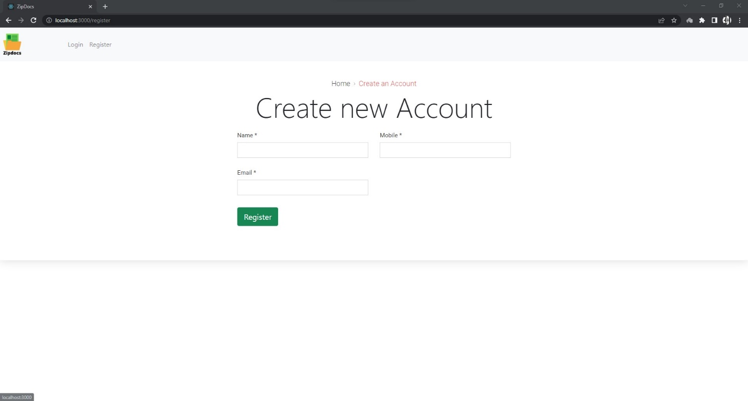

Figure 1(a) Register Consultant Page

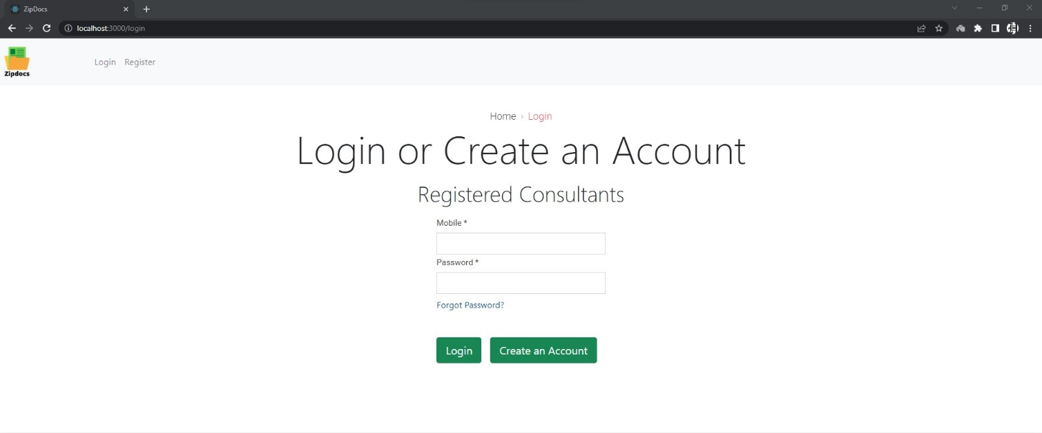

Figure 1(b) Login Consultant Page

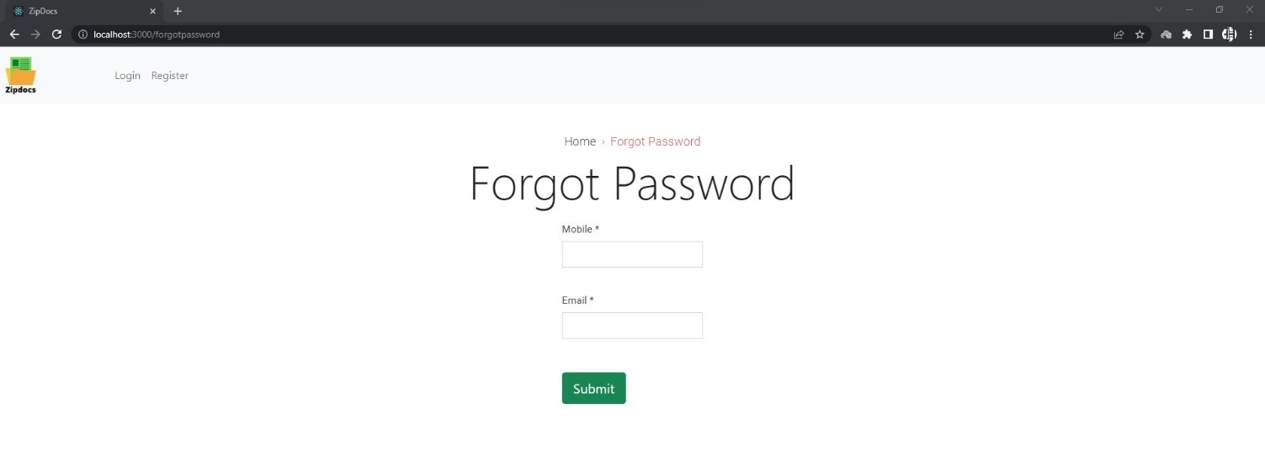

Figure 1(c) Forgot Password Page

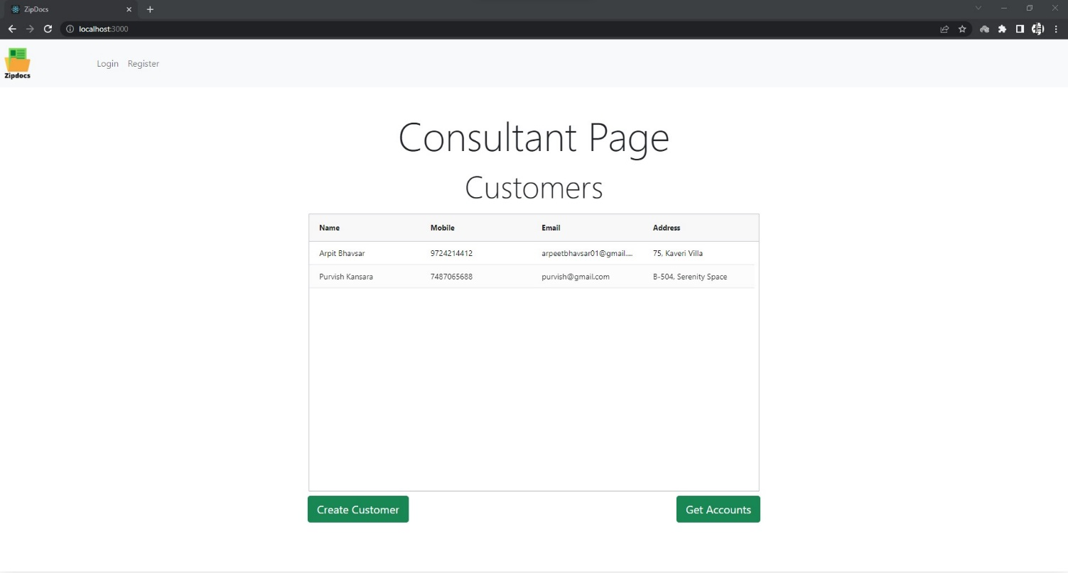

Figure 2(a) Consultant Home Page

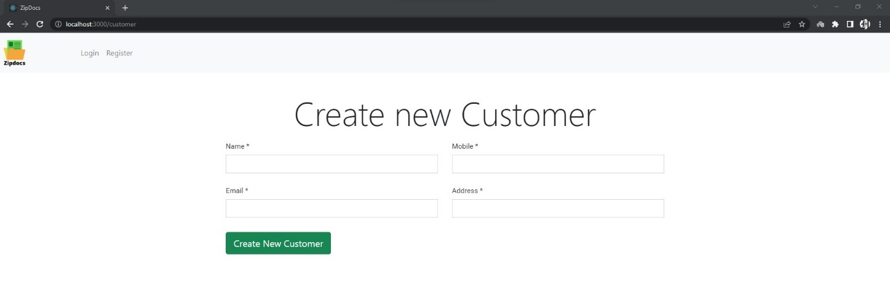

Figure 2(b) Create Customer Page

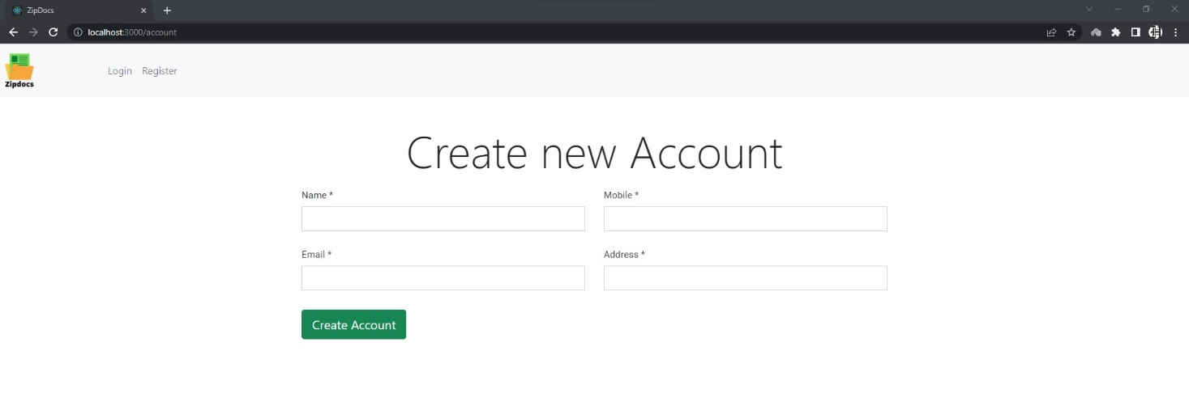

Figure 3(a) Create Account Page

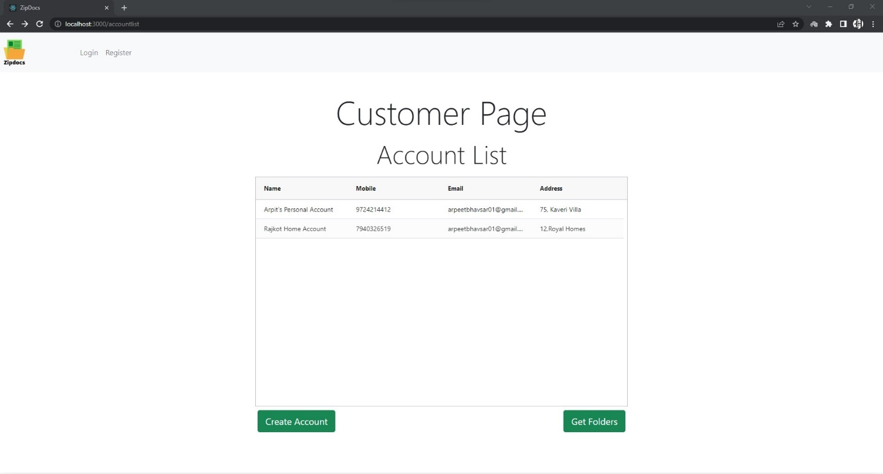

Figure 3(b) Account List Page

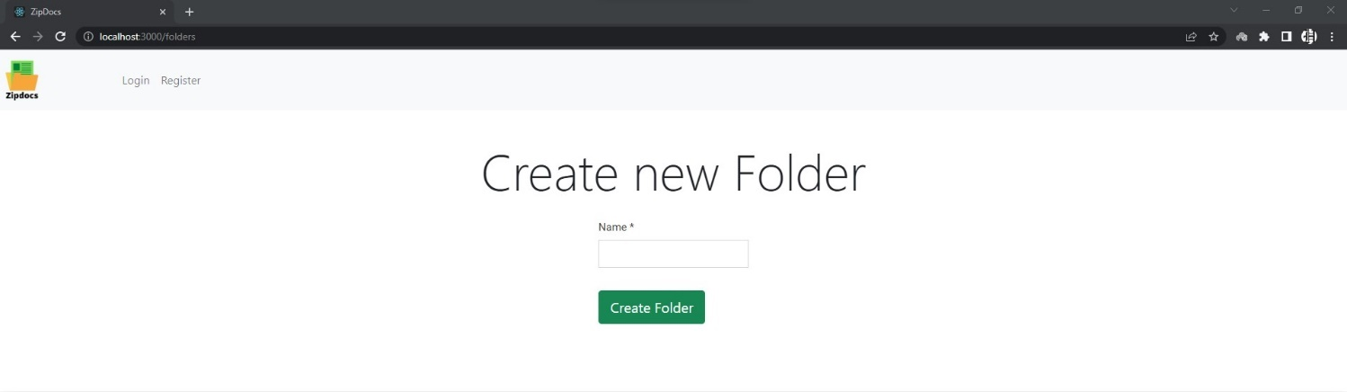

Figure 4(a) New Folder Page

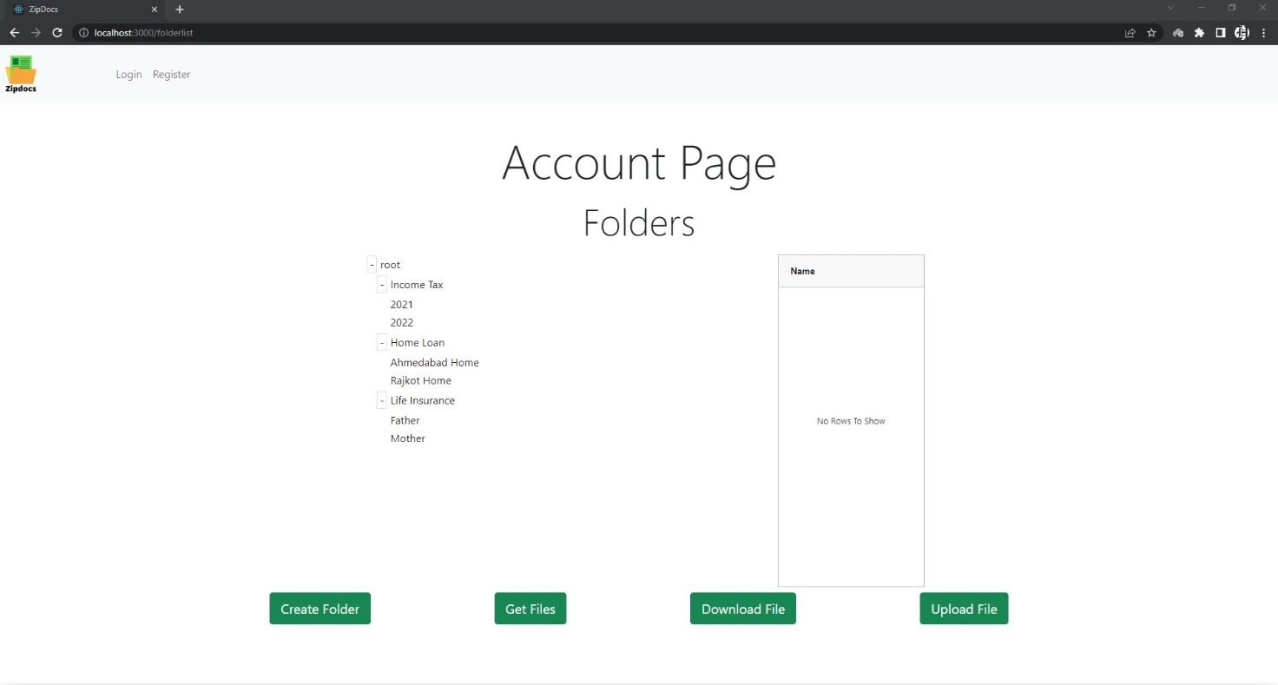

Figure 4(b) Folder List Page

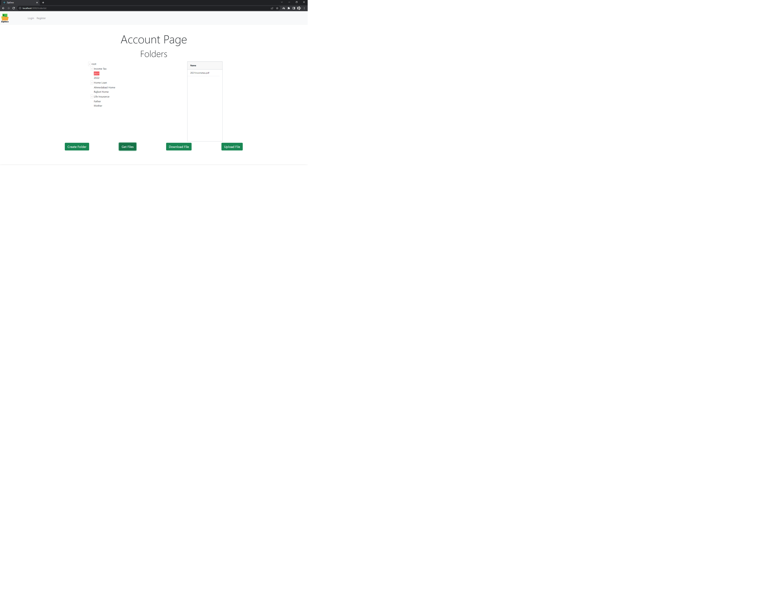

Figure 4(c) Get Files

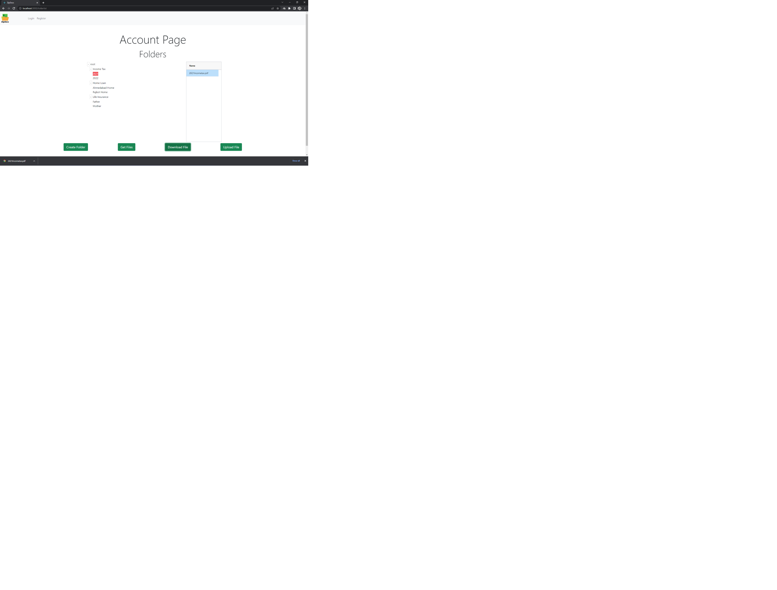

Figure 4(d) Download File

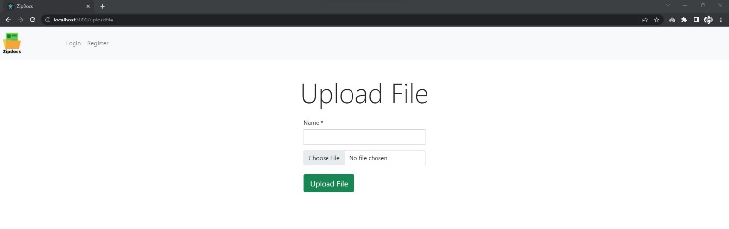

Figure 4(e) Upload File Page

## Design Code

1. Backend :

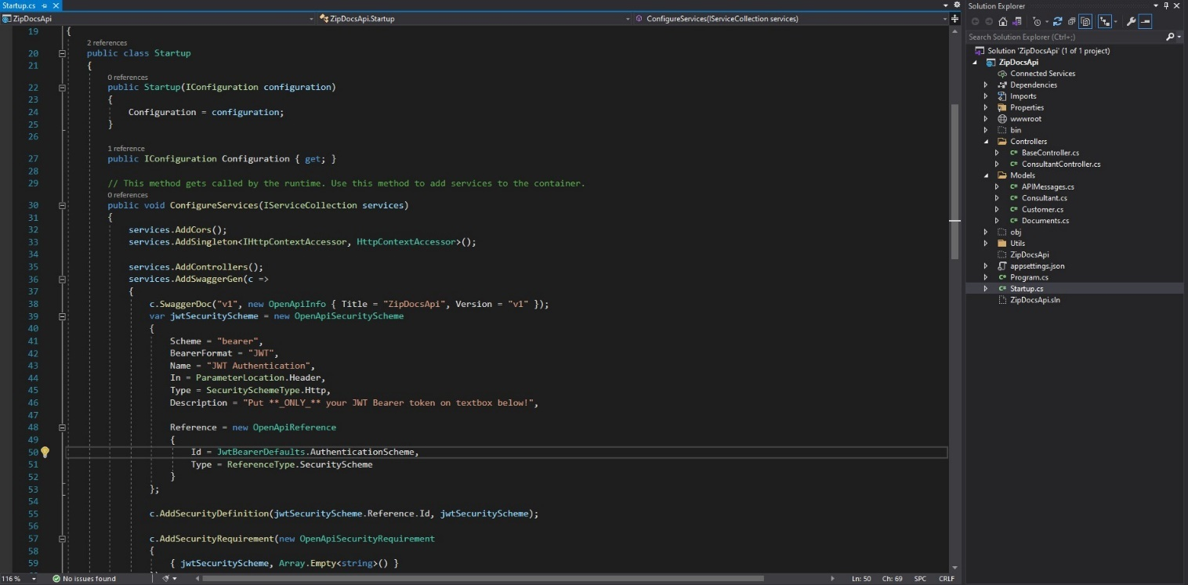

Figure 5(a) Startup.cs

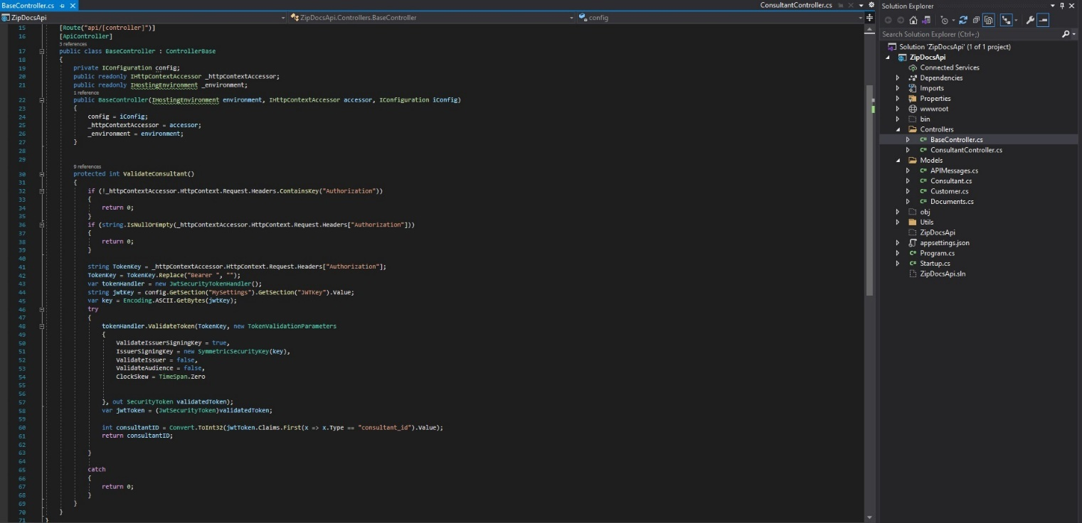

Figure 6(a) BaseController.cs

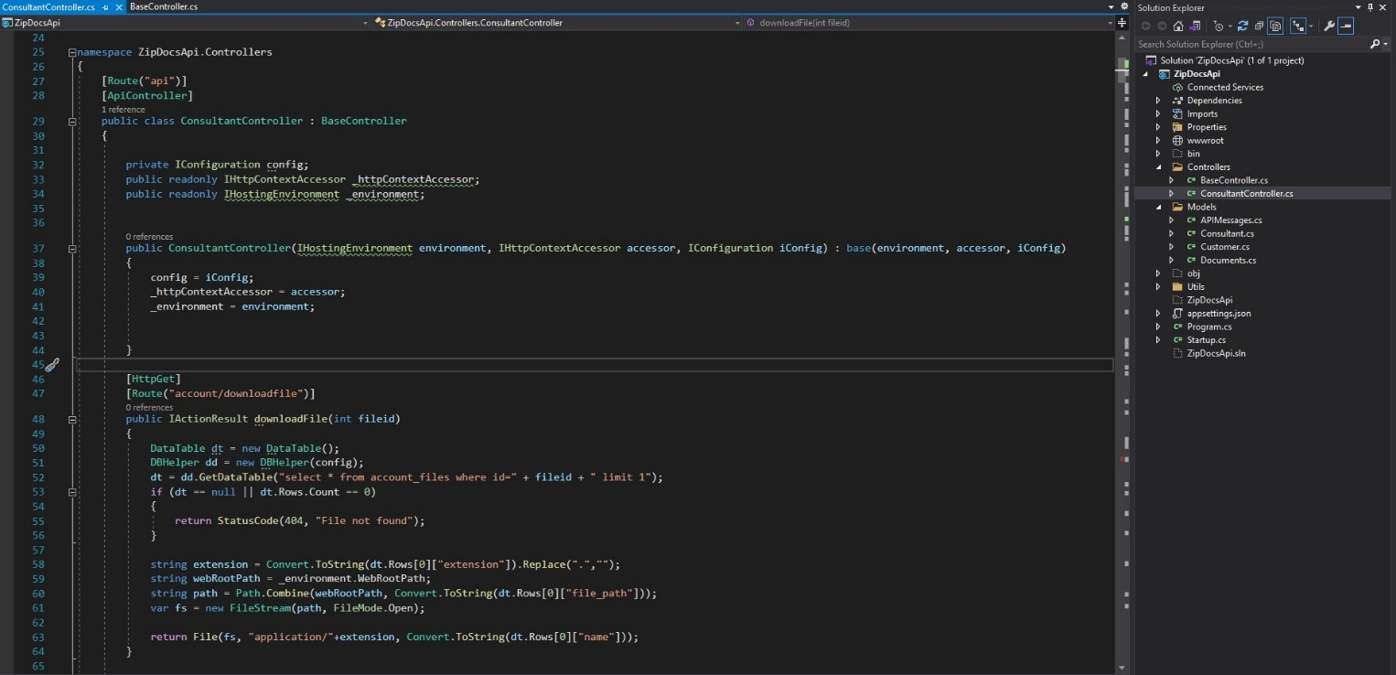

Figure 7(a) ConsultantController.cs Download File

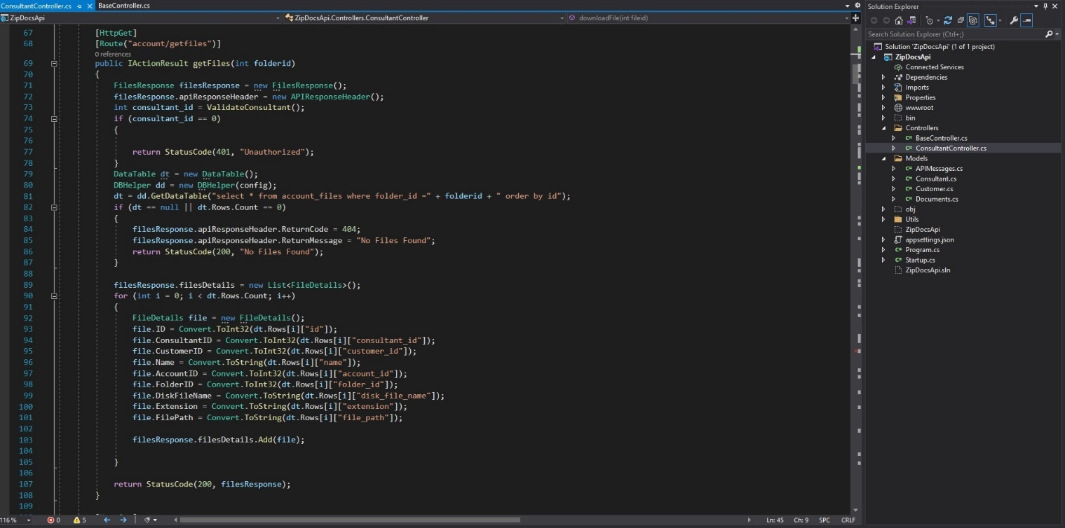

Figure 7(b) ConsultantController.cs Get Files

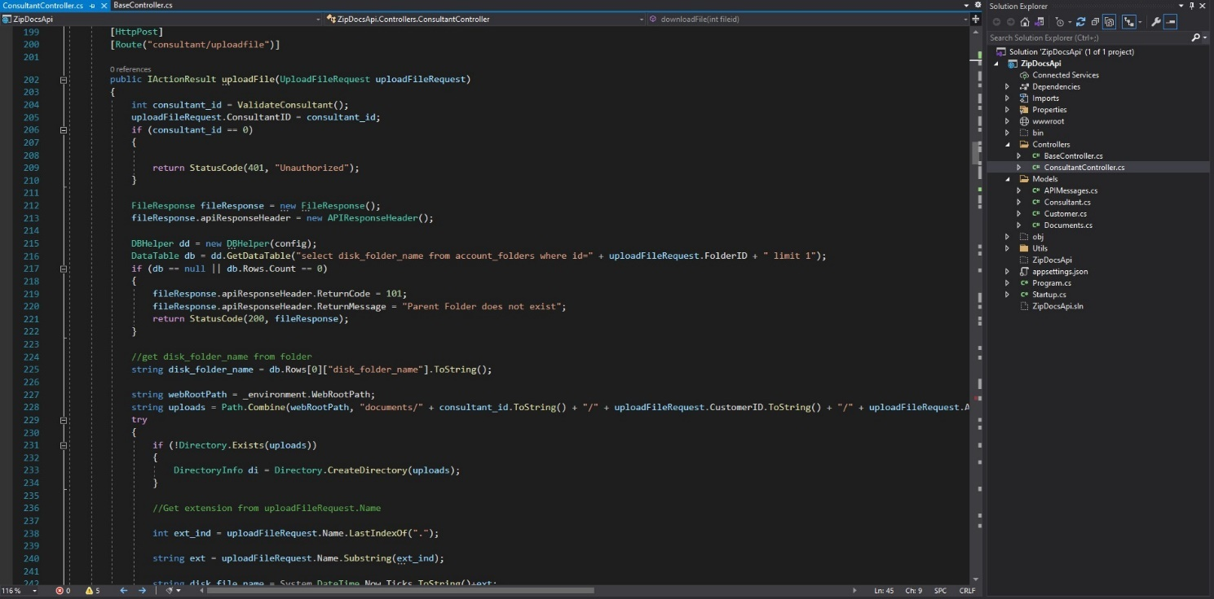

Figure 7(c) ConsultantController.cs Upload File-1

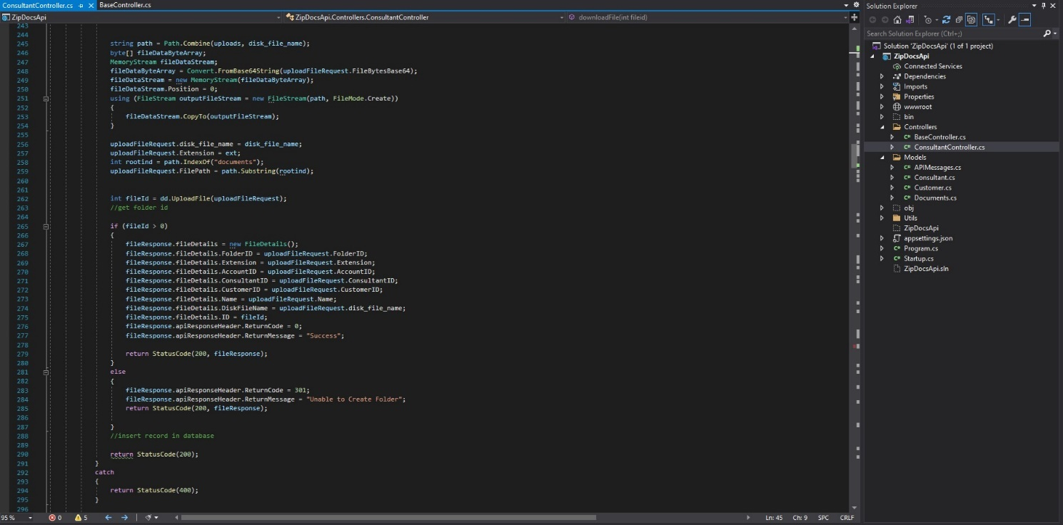

Figure 7(d) ConsultantController.cs Upload File-2

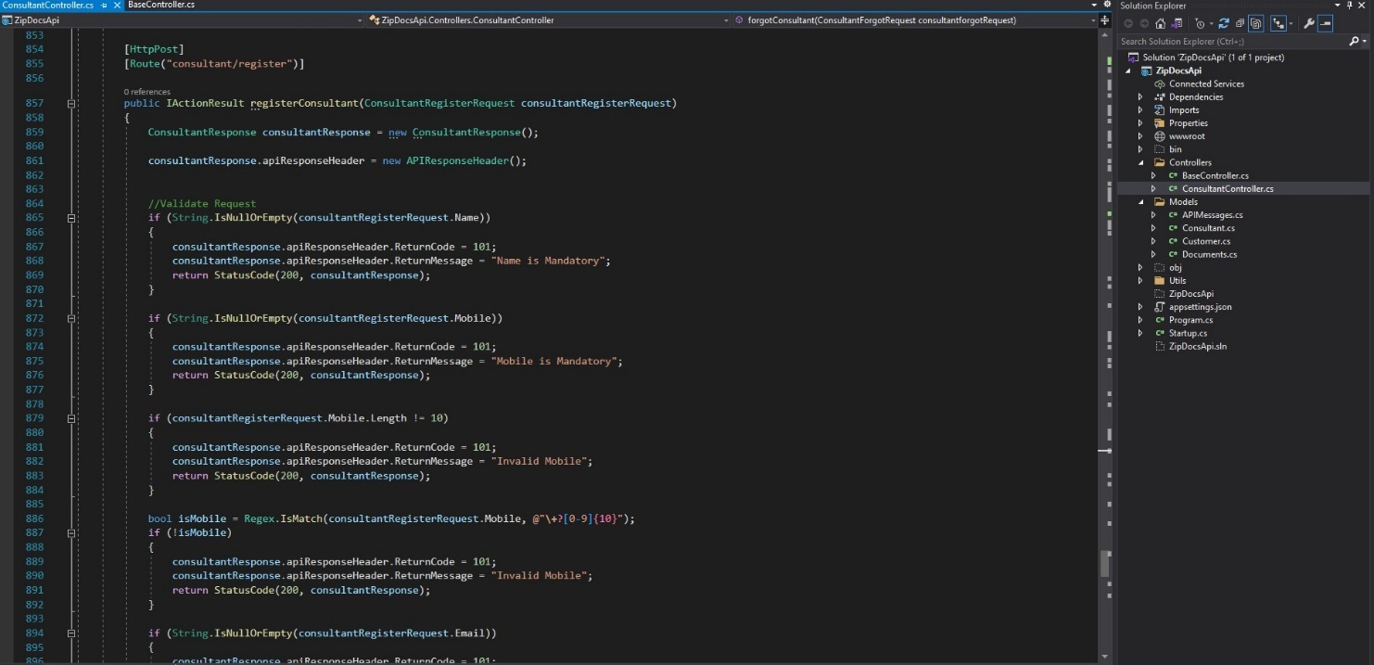

Figure 7(e) ConsultantController.cs Register-1

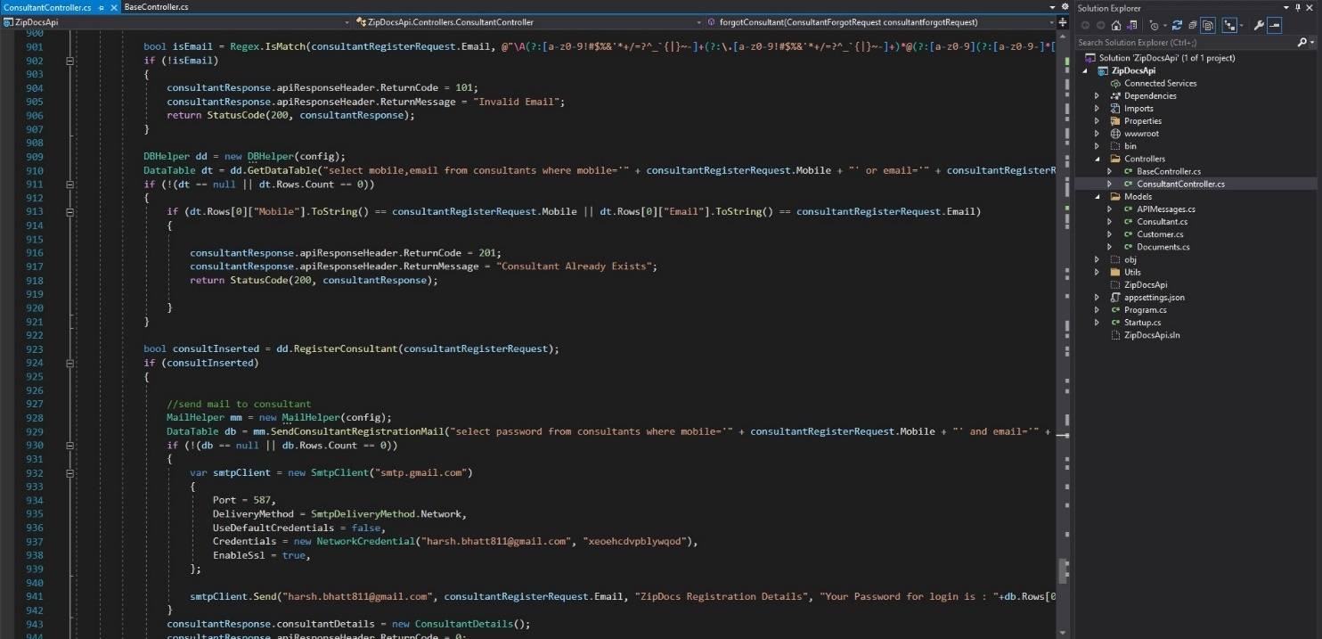

Figure 7(f) ConsultantController.cs Register-2

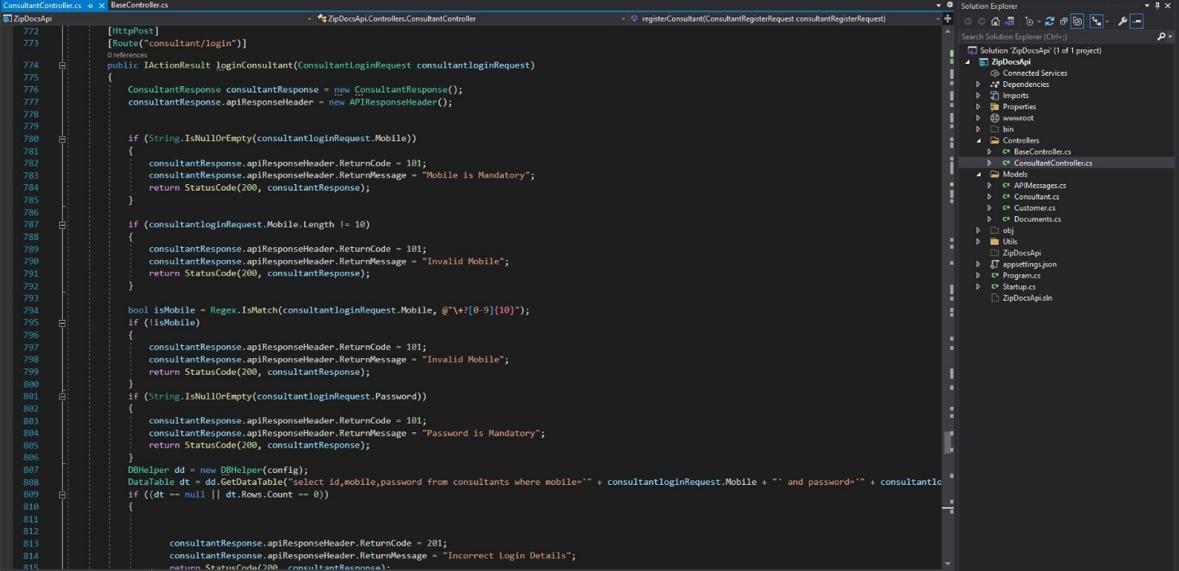

Figure 7(g) ConsultantController.cs Login-1

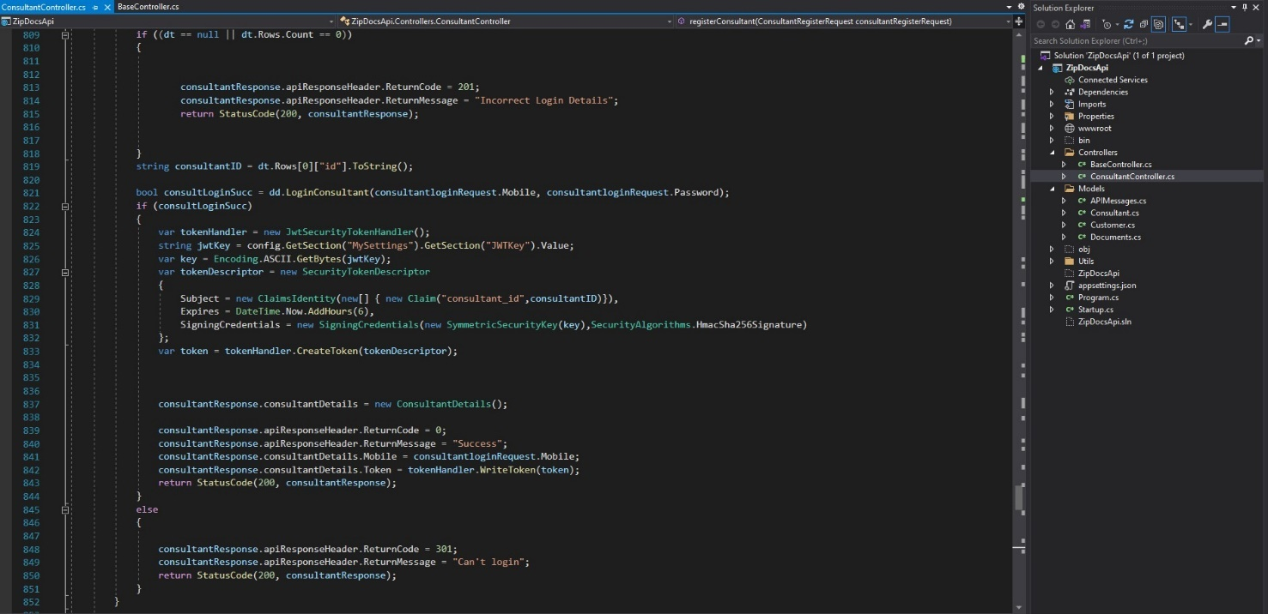

Figure 7(h) ConsultantController.cs Login-2

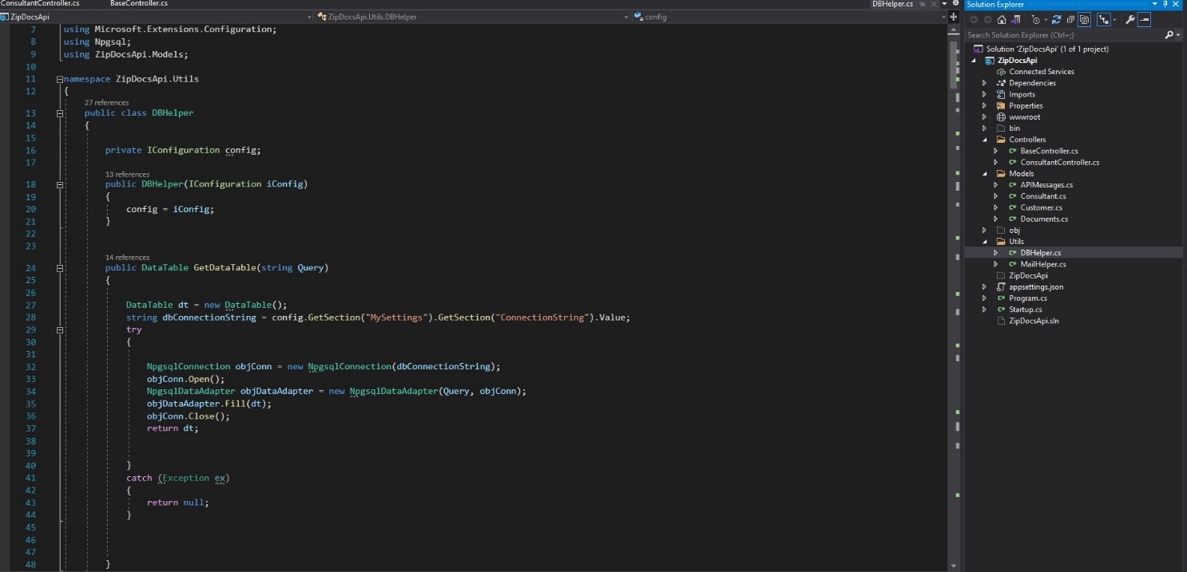

Figure 8(a) DBHelper.cs

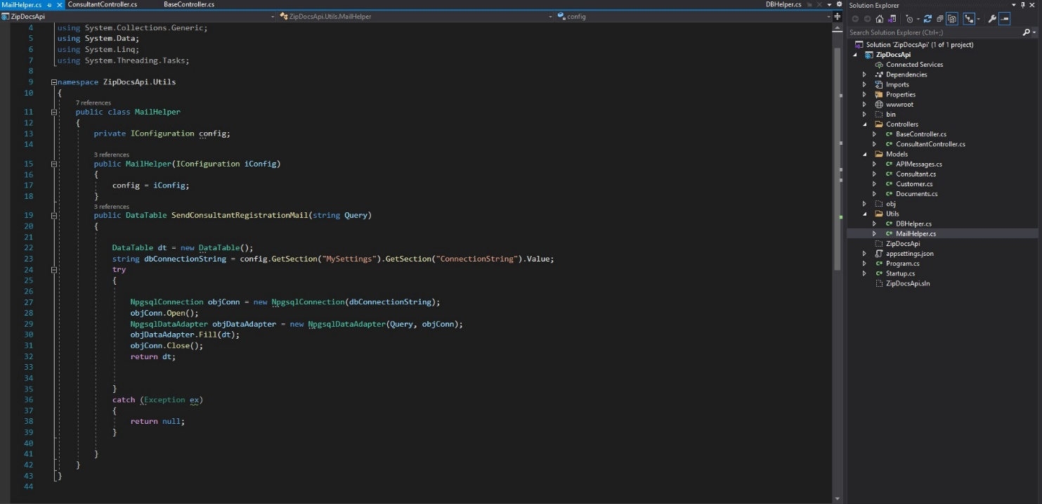

Figure 8(b) MailHelper.cs

1. Frontend:

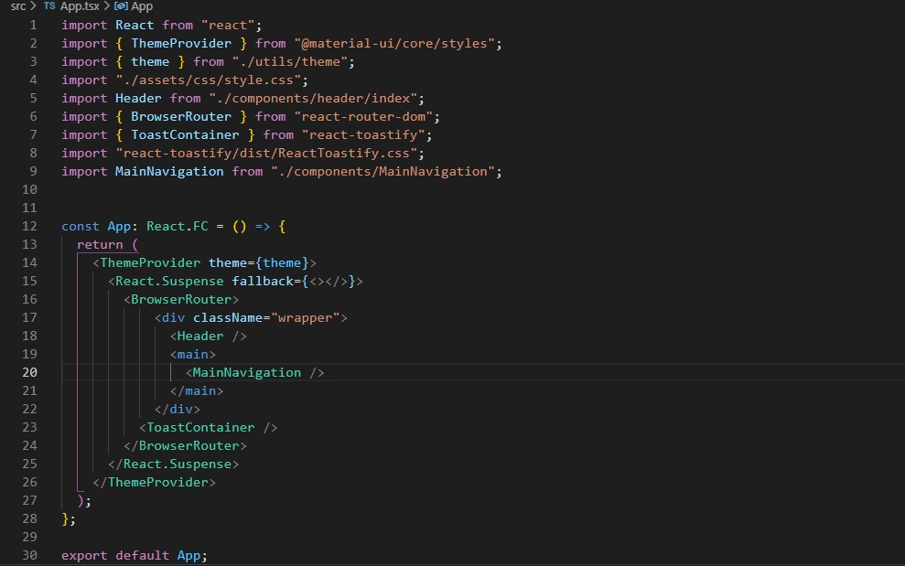

Figure 9(a) App.tsx

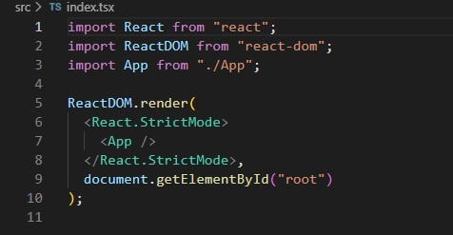

Figure 10(a) index.tsx

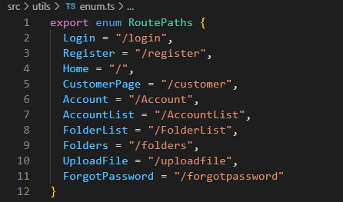

Figure 11(a) enum.ts (Route Paths)

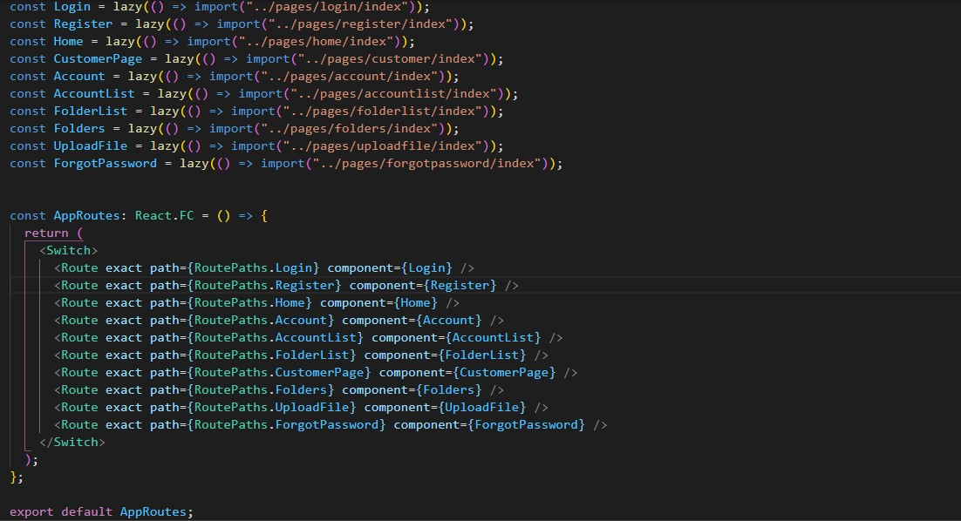

Figure 11(b) MainNavigation.tsx

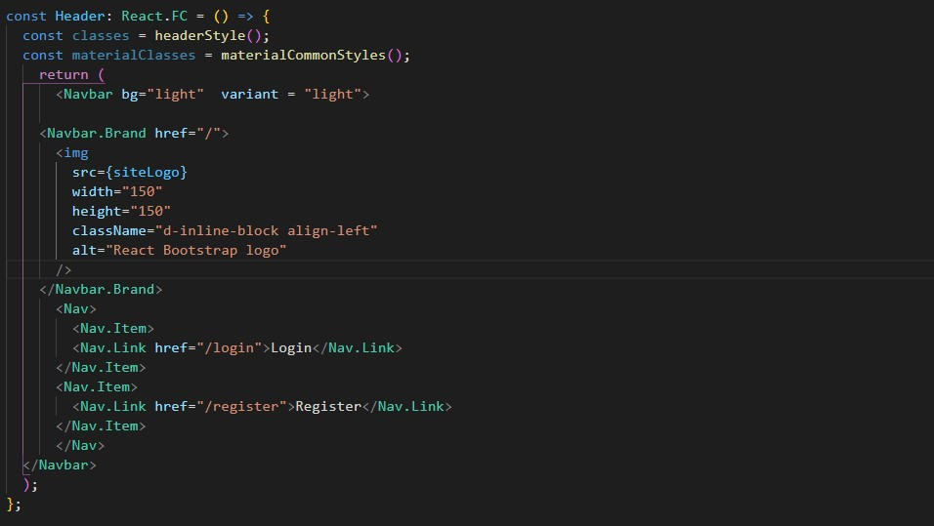

Figure 12(a) Header.tsx

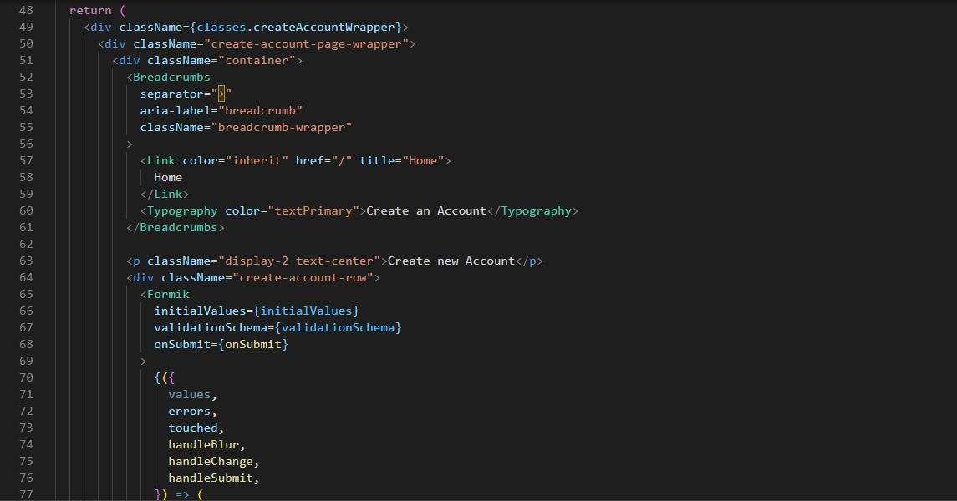

Figure 13(a) Register-1 index.tsx

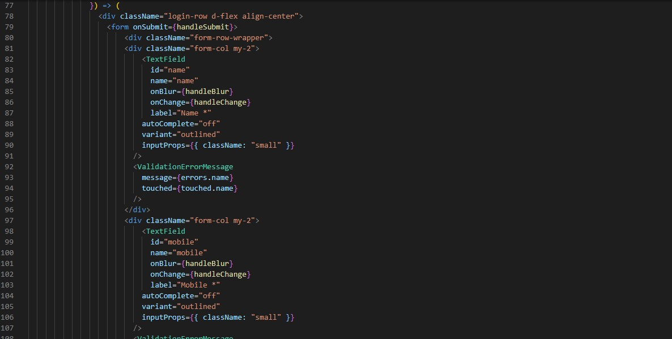

Figure 13(b) Register-2 index.tsx

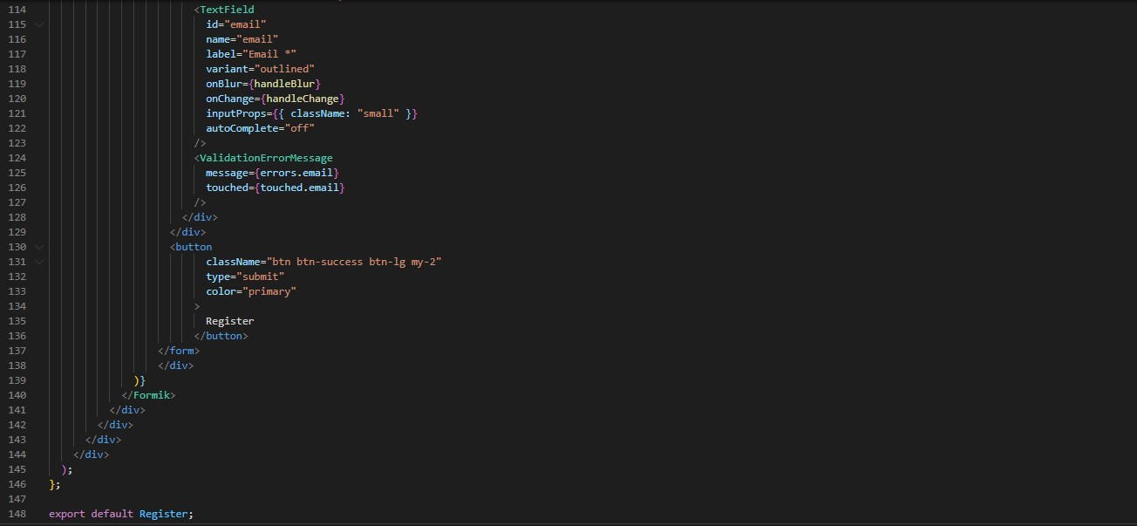

Figure 13(c) Register-3 index.tsx



Figure 14(a) Login index.tsx

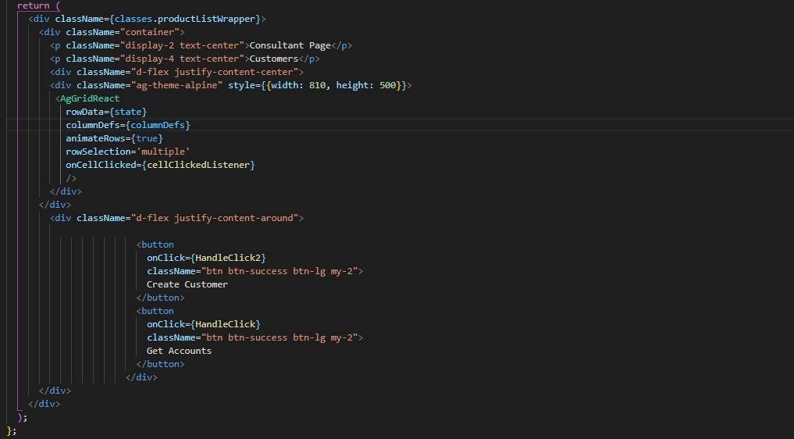

Figure 15(a) Home index.tsx

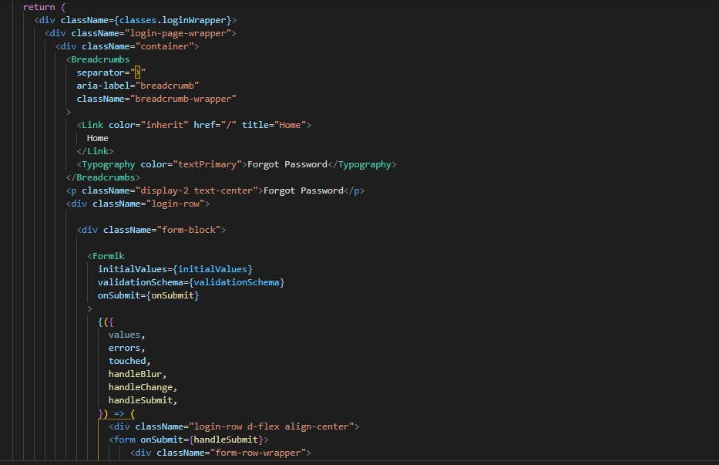

Figure 16(a) Forgot Password index.tsx



Figure 17(a) Customer index.tsx



Figure 18(a) Accountlist-1 index.tsx

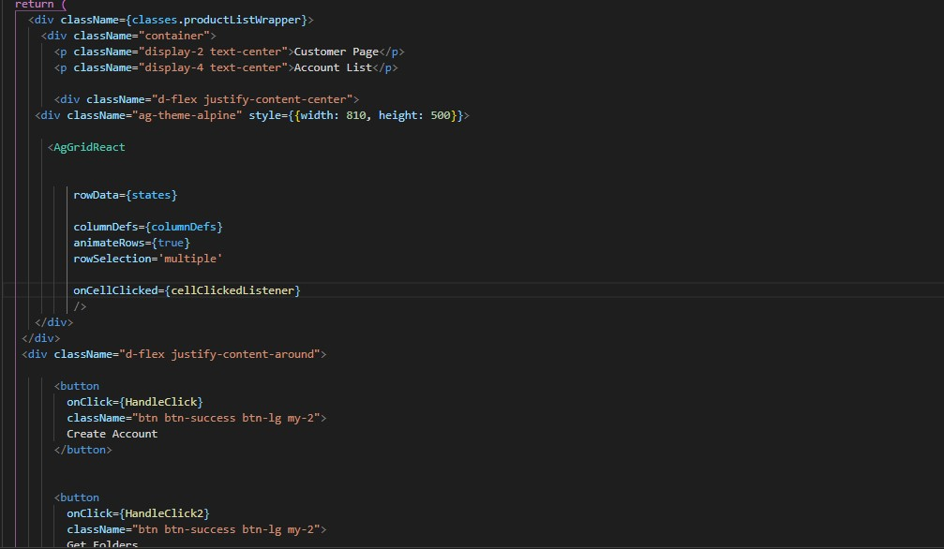

Figure 18(b) Accountlist-2 index.tsx

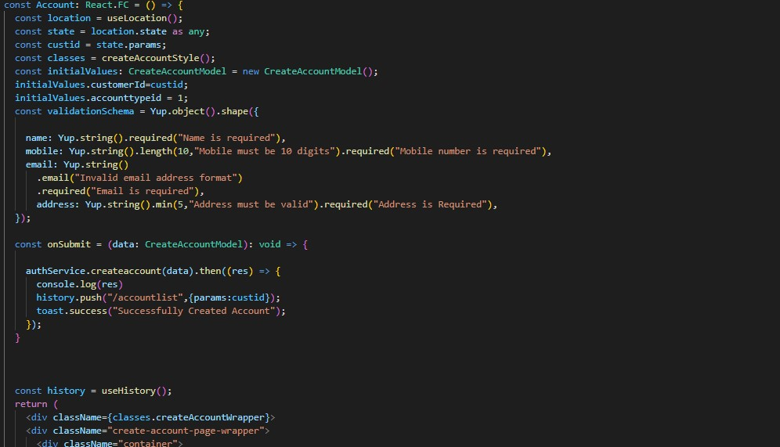

Figure 19(a) Account index.tsx

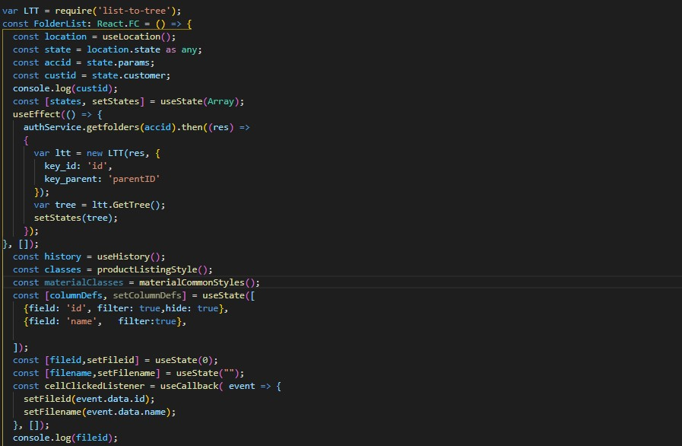

Figure 20(a) Folderlist-1 index.tsx

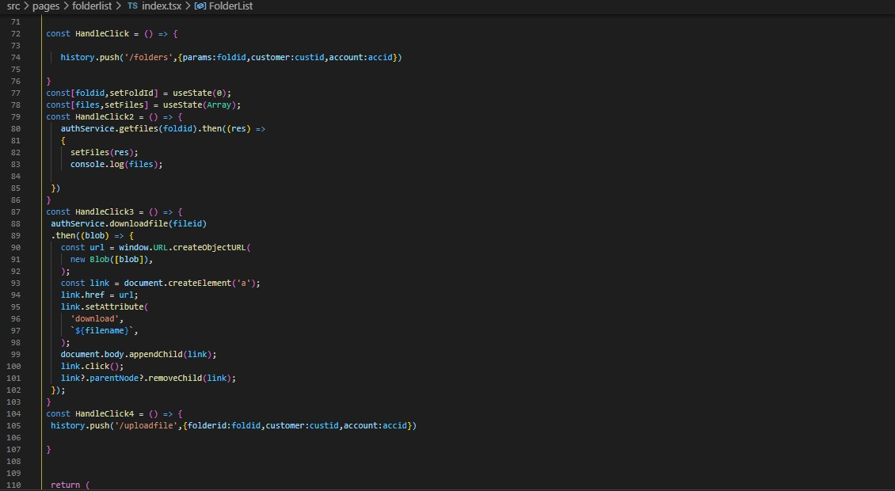

Figure 20(b) Folderlist-2 index.tsx

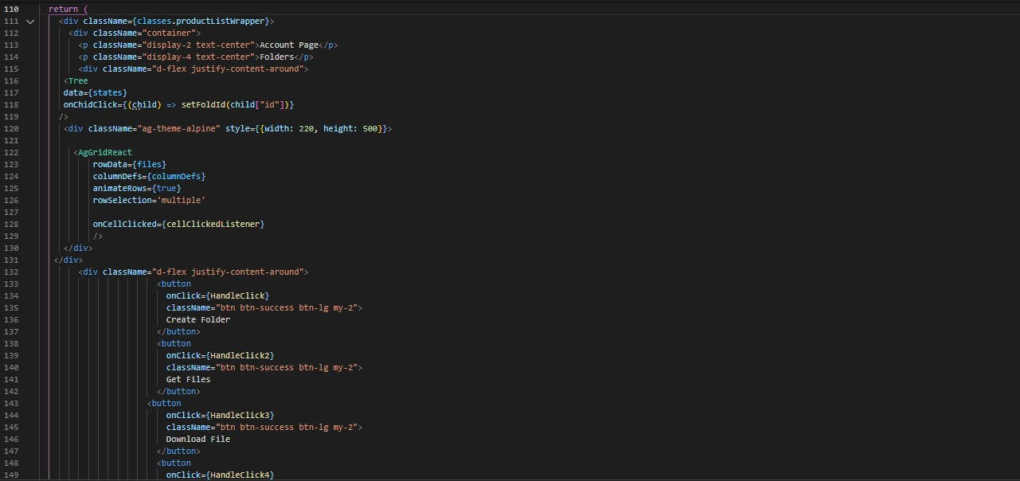

Figure 20(c) Folderlist-3 index.tsx

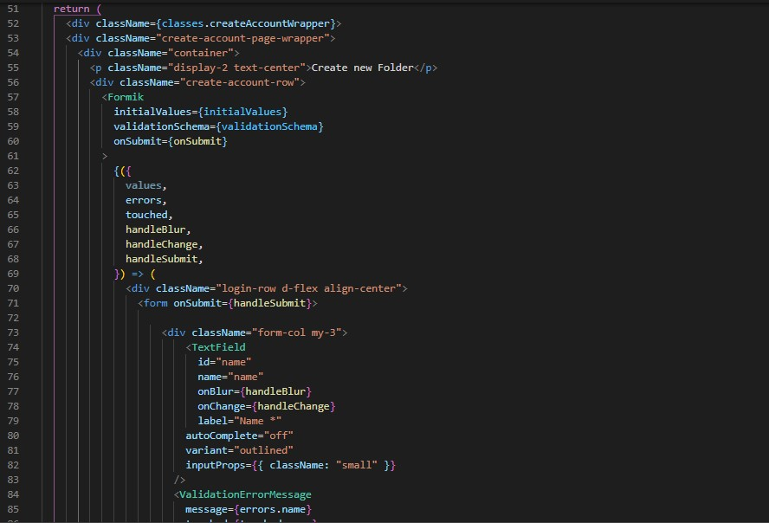

Figure 21(a) Folders index.tsx

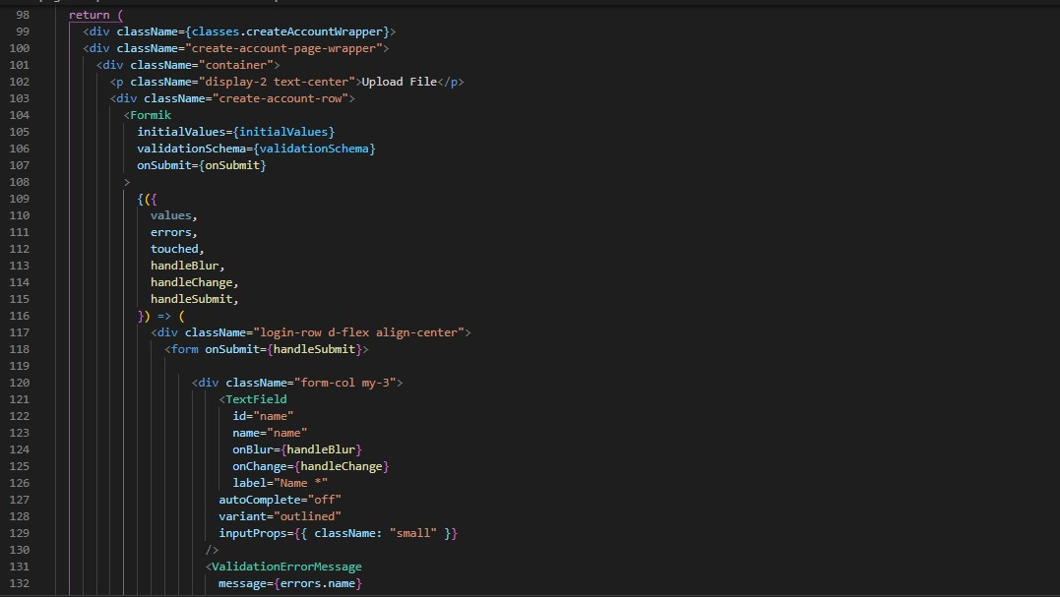

Figure 22(a) uploadfile index.tsx

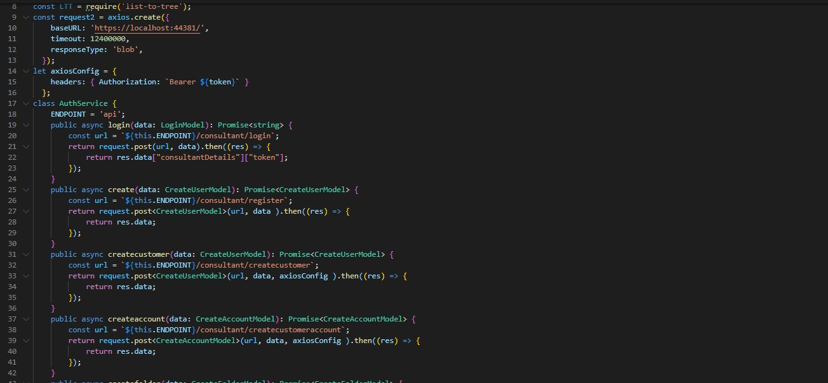

Figure 23(a) auth.service.ts -1

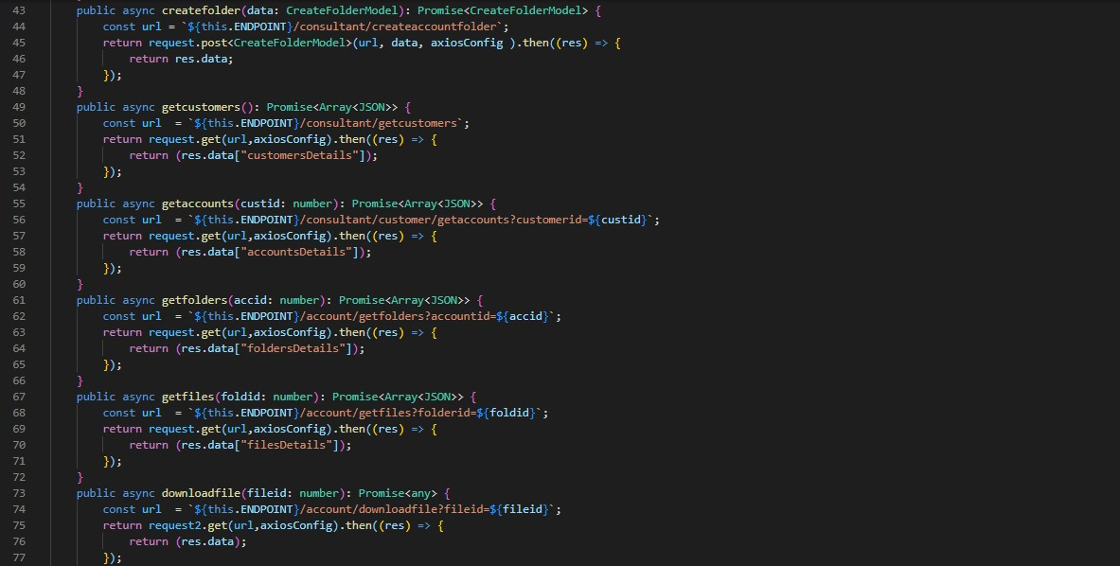

Figure 23(b) auth.service.ts -2

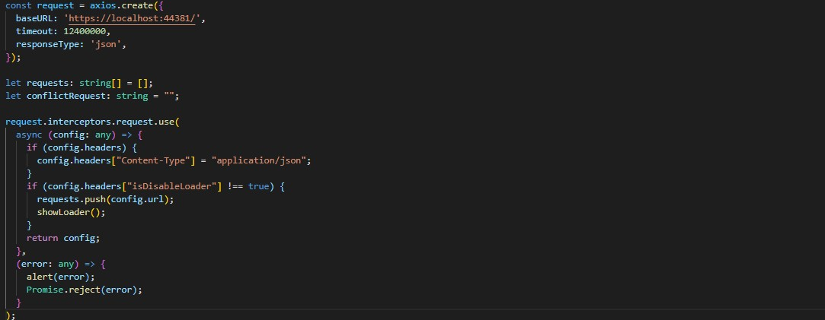

Figure 24(a) request.ts

## Results and Discussion

As seen above from the data dictionary, design snapshots and design code, This Project contains three main parts : The Database, Backend and Frontend.

The Database is connected to the backend and the various API methods in the controller make changes to the database.

These same API methods are also called from the Frontend with the help of Axios Library in React. JWT Authentication is also added to secure it. CORS is enabled in backend so that frontend can make API calls without getting blocked.

ag-Grid library has been used in Frontend to be able to show various kinds of data received from backend in JSON as a table.

list-to-tree library has been used to convert JSON data with parent_id to a tree like structure. This tree structure is then represented by using the react-custom-tree library.

The Files are encoded in Base64 format before being uploaded. This Base64 string is then stored on to the database so that it can be accessed easily. The extension of the file such as .pdf, .jpg etc. is also stored in the database so that we can know the file type.

# Future Enhancement

In the future, Cloud Storage Functionality can be Implemented so that the folders and files can be stored on Google Cloud or Microsoft Azure Cloud Storage and so on.

Additionally, Customer Login can also be implemented in which the customer only has read-only access to his files and can upload files to a predefined customer folder only.

A Storage Limit can also be added to each consultant so that they do not upload too many files and increase storage costs on the server or exceed their computer storage.

This limit can be changed by an admin panel implementation where we can also remove consultants from the software if they stop their subscription.

# Summary/Conclusion

ZipDocs gives the various consultants the ability to easily add customers and make multiple accounts for each customer according to their needs. They can then make numerous folders and upload files to them. The file name can be different from the actual file being uploaded for easier management and access. These files can also be quickly downloaded in a single click of a button.

In the future even the customers will be able to download the files uploaded by the consultants and upload files by themselves to a pre-defined folder. Cloud Storage functionality can also be implemented so that there will always be a backup of the files which will remain secure.

# References

Postgres : <https://youtube.com/playlist?list=PLk1kxccoEnNEtwGZW-3KAcAlhI_Guwh8x>

.Net Core : <https://youtube.com/playlist?list=PLaFzfwmPR7_IPzBR4AI0eoojmIdTFJmHs>

Typescript: <https://youtube.com/playlist?list=PL8p2I9GklV46OtmTnYKPa2Mp9sPLWpRA->

React: <https://youtube.com/playlist?list=PLC3y8-rFHvwi1AXijGTKM0BKtHzVC-LSK>

React-bootstrap Library : <https://react-bootstrap.github.io/getting-started/introduction>

React Axios Library: <https://www.npmjs.com/package/react-axios>

React Toastify Library: <https://www.npmjs.com/package/react-toastify>

React Formik Library: <https://formik.org/docs/tutorial>

React Yup Library: <https://www.npmjs.com/package/yup>

React-json-to-table Library : <https://www.npmjs.com/package/react-json-to-table>

React-custom-tree-library : <https://www.npmjs.com/package/react-custom-tree>

React AGgrid library : <https://www.ag-grid.com/react-data-grid/>